NAME : B Tharun kumar reddy

REG NO :192111508

Course : software engineering

Code : CSA1001

Faculty name :DR G Mary valantina

Date :29/09/2022

17.Draw and validate the flowchart to compute the quotient and remainder.

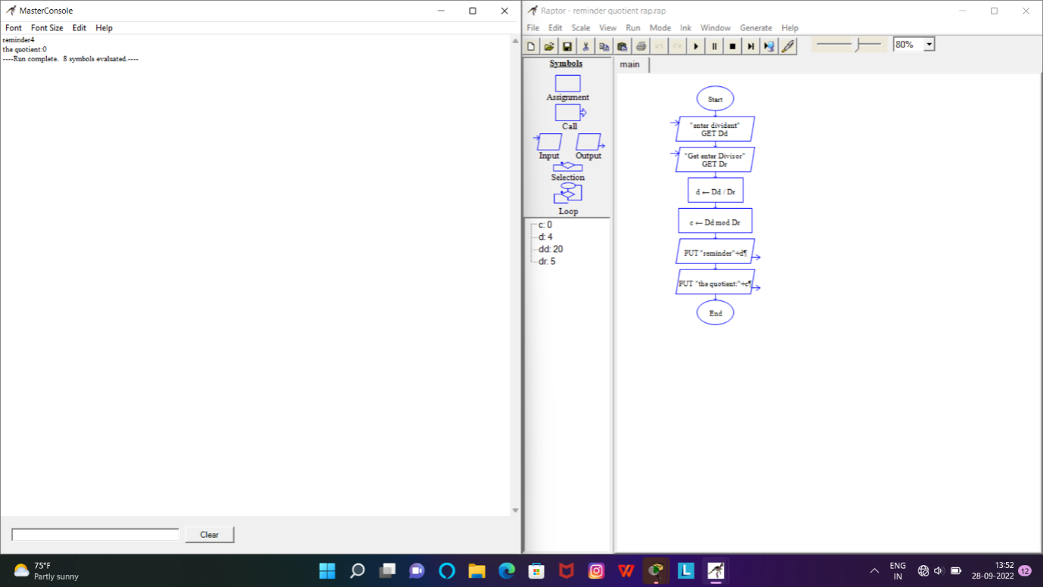

18.Using Raptor- Draw and validate the flowchart to calculate Fibonacci series

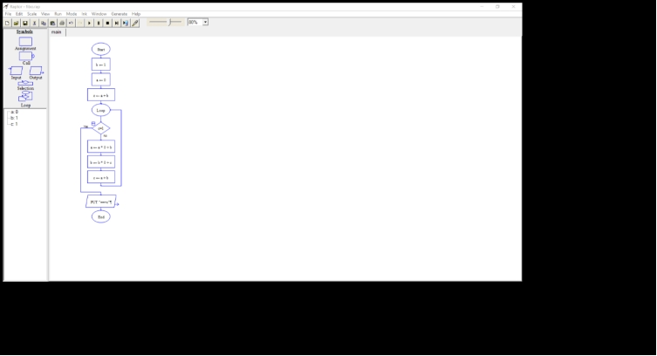

20.Using Raptor – Draw and validate the flowchart to swap two characters.

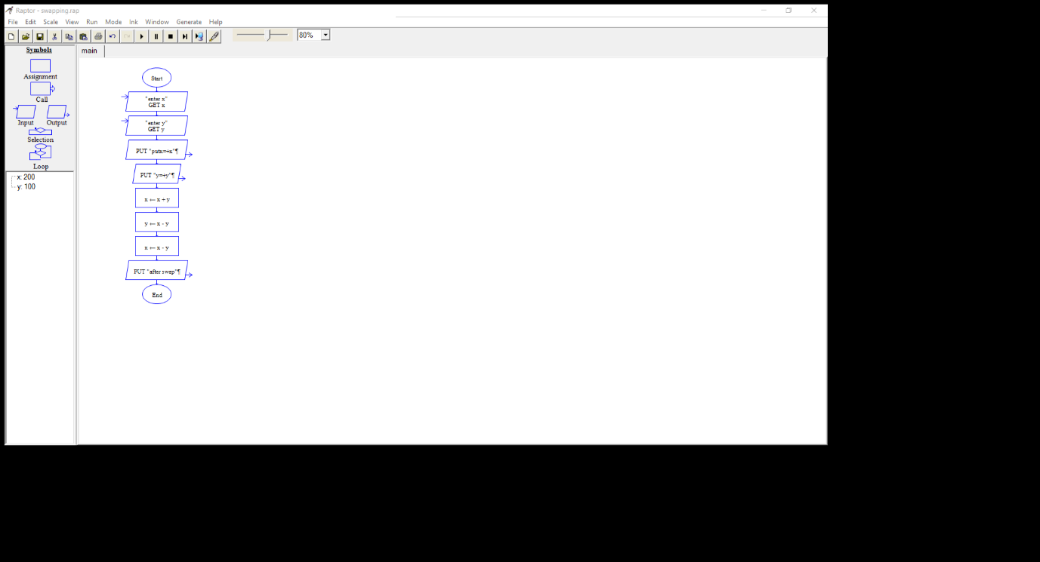

21.Using Raptor – Draw the flowchart to display the length of the string.

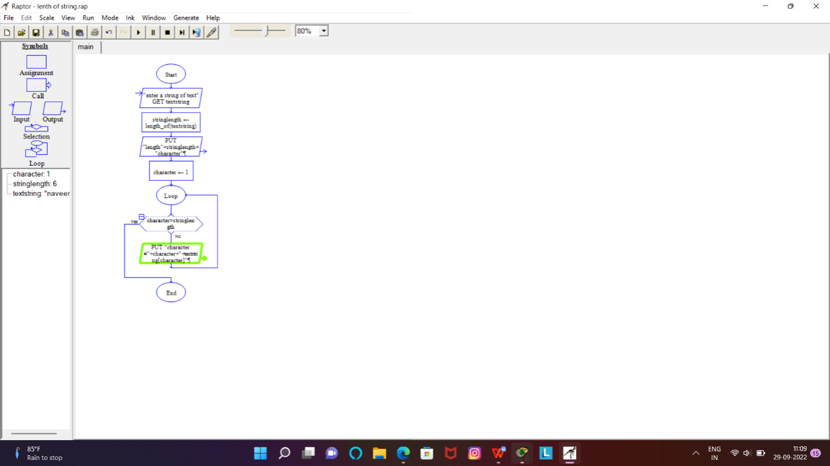

22.Using Raptor – Draw the flowchart to find whether the given number is prime or not.

